

**STUDENT NAME:** RASHWANTH KP

# SEAT NO: 190 PROJECT ID: 30

**PROJECT TITLE:** IIPC DASHBOARD

**TECHNICAL COMPONENTS**

|  |  |
| --- | --- |
| **COMPONENTS** | **TECH STACK** |
| Backend | Django |
| Frontend | Html, CSS |
| Database | MySQL |

**PROBLEM STATEMENT:**

Design and develop a user-friendly dashboard to keep tracks on visits from industry professionals. A digital guest book which stores the records about their visit and the coordinator who invited him. This dashboard simplifies the process of storing and accessing the information, maintaining organized records for future reference. By centralizing the data, colleges can efficiently manage their visitor logs, ensuring accountability and facilitating communication among the staffs.

**FUNCTIONAL REQUIREMENTS:**

1. **User Registration and Authentication:** 
   * Faculty should be able to register and log in securely to the system.
   * User authentication mechanisms should ensure data privacy and security.
2. **Visitor Record Management:** 
   * The system should allow admin to record details to about visiting industry professionals and the coordinating staff members who invited them.
   * Information captured should include name, designation, domain, affiliated organization, purpose of visit and contact details.
3. **Data Management:** 
   * The system should securely store and manage records of all visitor interactions.
   * Data should be easily accessible for reporting and analysis purpose.
4. **Accessibility and User Interface:**

o The system should feature a user-friendly interface accessible vis desktop and mobile devices.

1. **Searching and Filtering:**
   * Users should be able to search and filter records based on various criteria such as domain, date of visit and purpose of visit.
2. **Reporting and Analytics:**

* The system should generate reports on visitor trends, frequency of visits, and other relevant analytics.

1. **Admin Panel:**

* Administrators should have access to a dashboard for managing user accounts, permissions, and system settings.
* They should be able to generate reports on visitor statistics and manage data privacy settings.

**SYSTEM OVERVIEW:**

**1.Users:**

**Certainly, let's outline the roles and responsibilities for each type of user:**

1. **Staffs:** 
   * **Responsibilities:**
   * Log in to the system using their credentials. View the dashboard to access the visitor records.
   * **Privileges:**

o Access to view all the records…

1. **Admins:** 
   * **Responsibilities:**
   * Log in to the system using their credentials.
   * Add visitor records for each visit.
   * Manage the data and ensure its accuracy and consistency. Perform regular backups of visitor records.
   * **Privileges:**

* Access to the administrative dashboard for managing user accounts, permissions, and system settings.
* Add, modify, or delete visitor records. Generate reports on visitor statistics.
* Configure system settings related to visitor management. Perform data backups and recovery.
* Access system logs and audit trails for security and compliance purposes.

**FUNCTIONAL PROTOTYPE:**

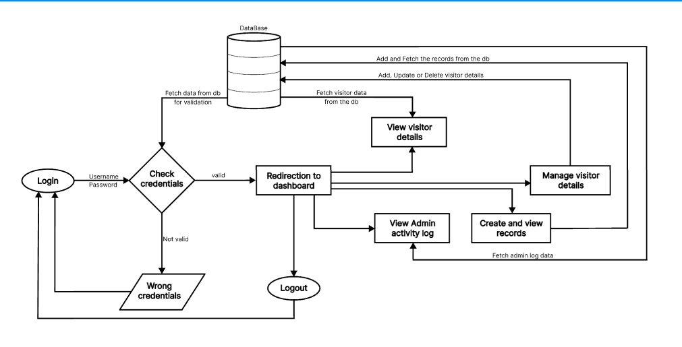

**WORKFLOW:**

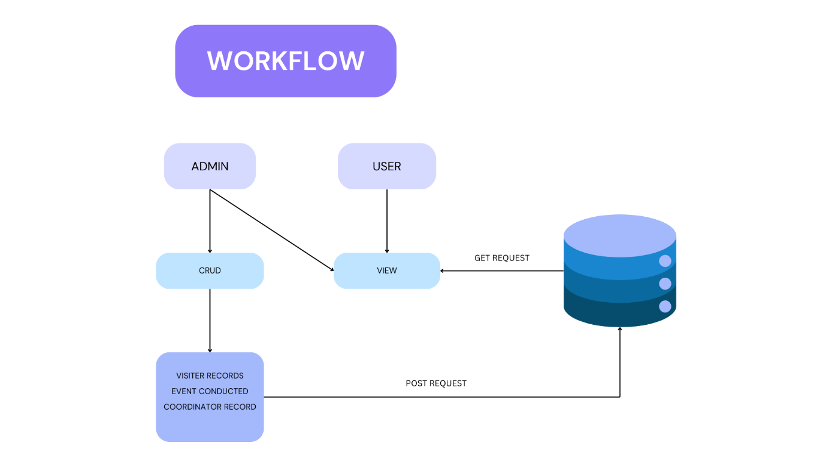

**DESIGN PROTOTYPE**

